Chapter 10, Solution 44.

Use superposition principle to obtain v_{x} in the circuit of Fig. 10.89. Let v_{s} = 50 sin2t V and i_{s} = 12 cos(6t + 10°) A.

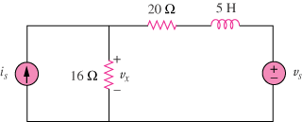

Figure 10.89
For Prob. 10.44.

Solution

Let , where v₁ and v₂ are due to the current source and voltage source respectively.

For v₁ , ,

The frequency-domain circuit is shown below.

20 j30

+
16 V₁
I_{s} -

Let
For v₂ , ,

The frequency-domain circuit is shown below.

20 j10

+
16 V₂ +
V_{s}
- -

Using voltage division,

Thus,
[147.7cos(6t+26.5°)+21.41sin(2t–15.52°)] V

